Company: Unlimited

Date: 2/16/2020

Members: Kehan Meng, Linsong Li, Shixian Jing, Nicholas Boanca

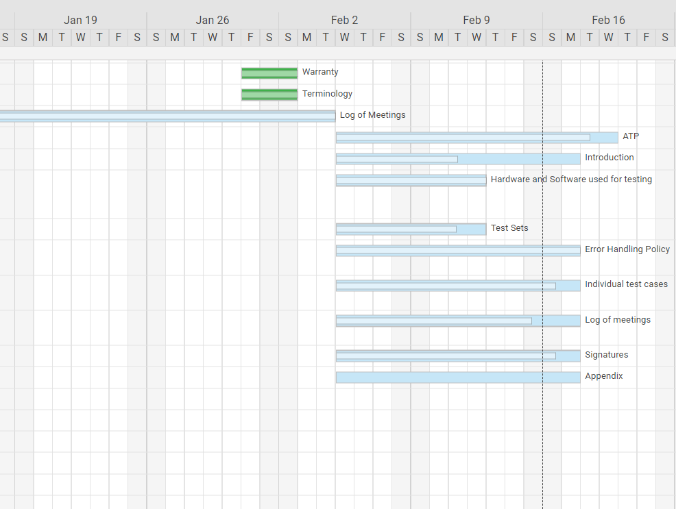

Work assignment:

Kehan Meng: Revise Error Handling Policy and set up coding environment.

Linsong Li: Write pseudo code for implementation.

Shixian Jing: Update log of meetings and appendix.

Nicholas Boanca: Update individual test cases, make system overview, expand purpose of ATP and organization of the document.